**Required software fro Mockup Demo Application**

1. UI design Software
   1. Tomcat Server
   2. Apache Maven
   3. Boostrap 4.3
   4. AngularJS
   5. JDK 1.8 / JRE 1.8
2. GIS
   1. Openmaptile Server
      1. Docker Quickstart Terminal
      2. Kitematic
      3. VM Virtual Box Manager

**Note :** Docker comes with Kitematic & VM virtual Box

* 1. Geoserver
     1. GeoServer
     2. Postgre SQL
     3. GIS DB – “postgis-bundle-pg94x64-setup-2.5.1-1.exe”
  2. ArcGIS API for JavaScript 3.28

1. BIS

**To launch Mockup Demo**

To start the following servers before launch the application.

1. Tomcat
2. Docker
3. Kitematic
4. GeoServer
5. Copy **arcgis api java scriptfolder** to server folder where you deploy (tomcat /webapp/youfolder/ and paste **arcgis api java scriptfolder**

# OpenMapTile Server – setup and region selection

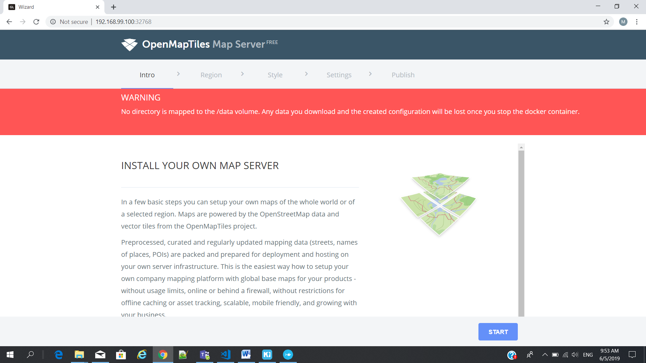

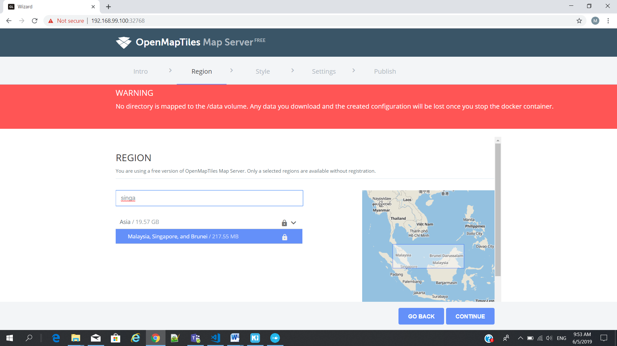

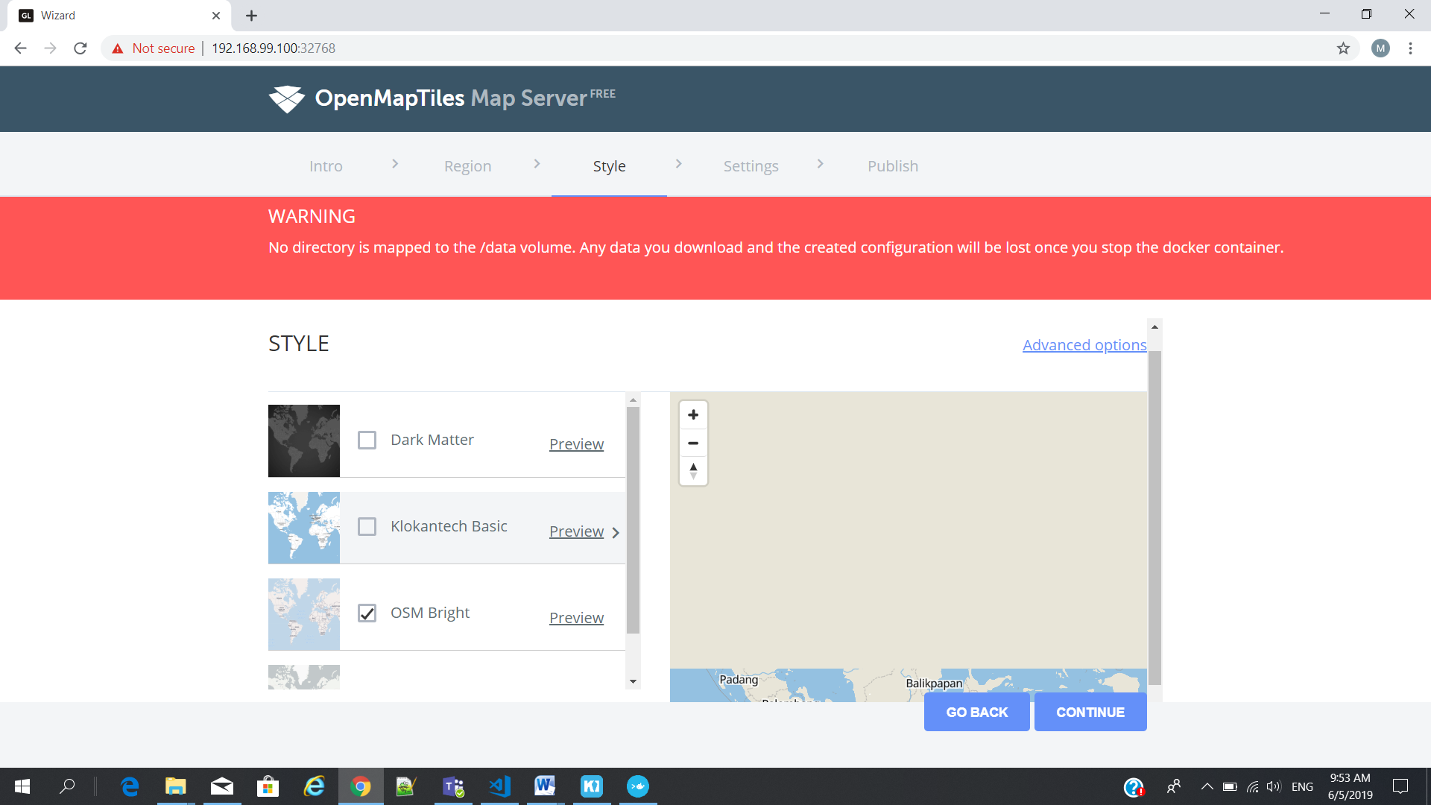

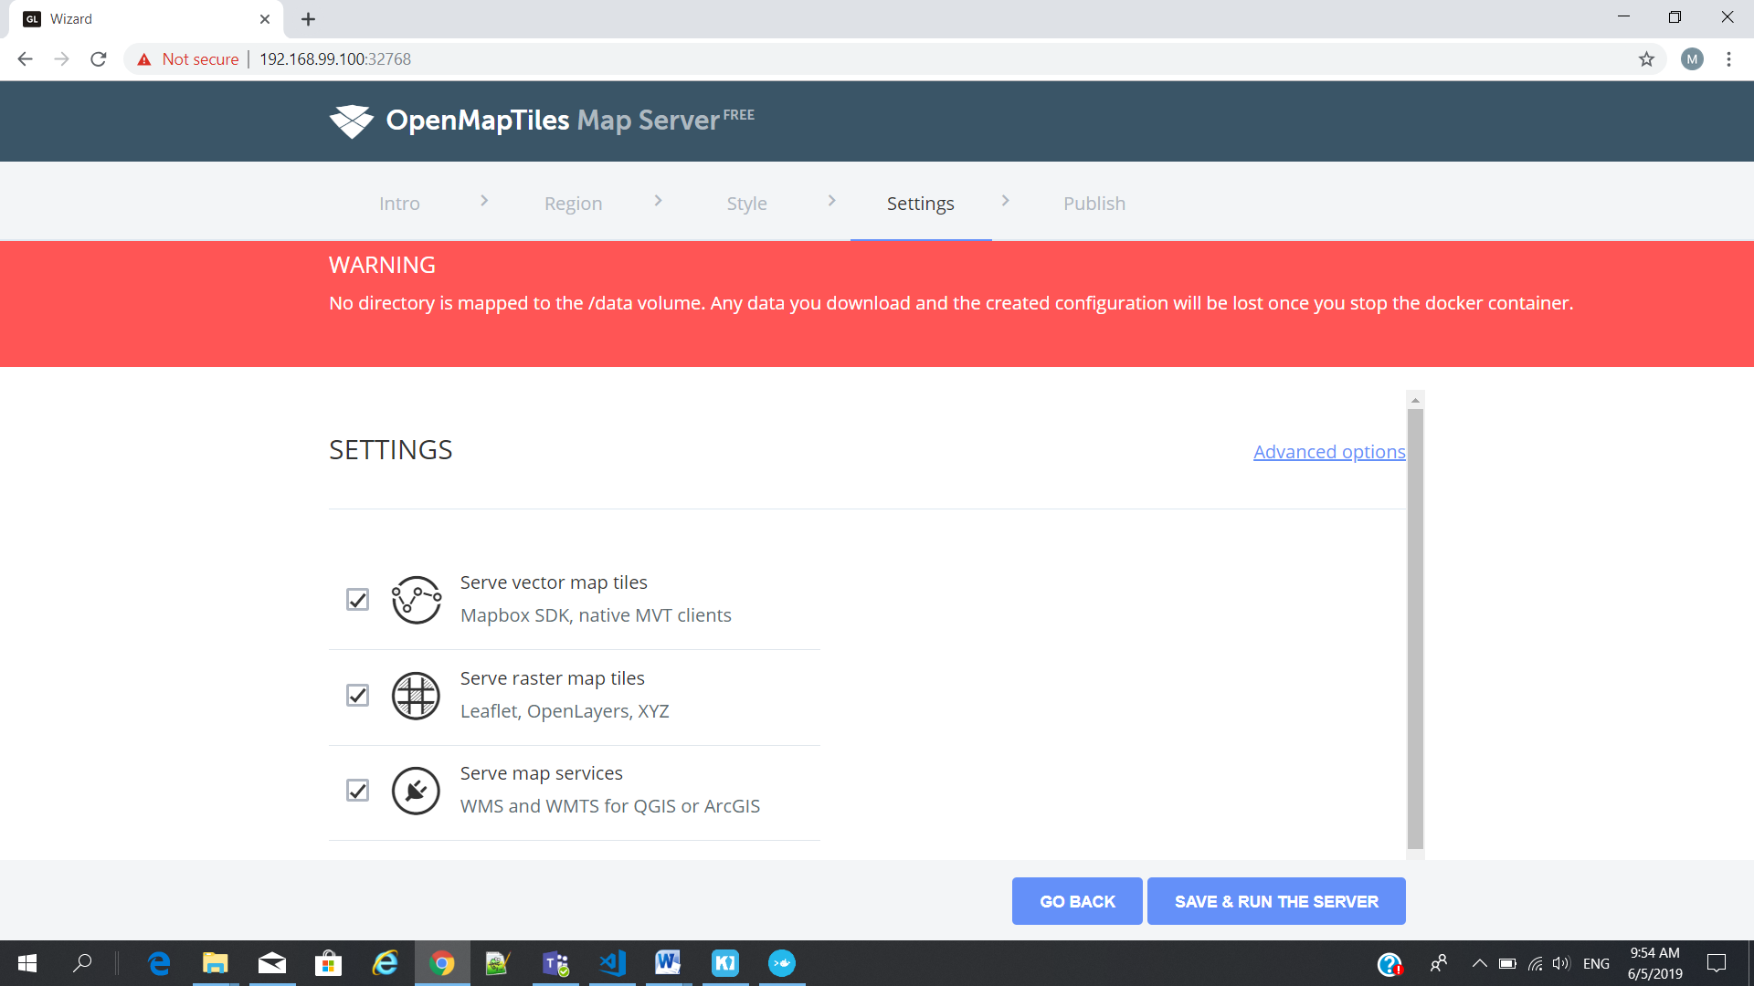

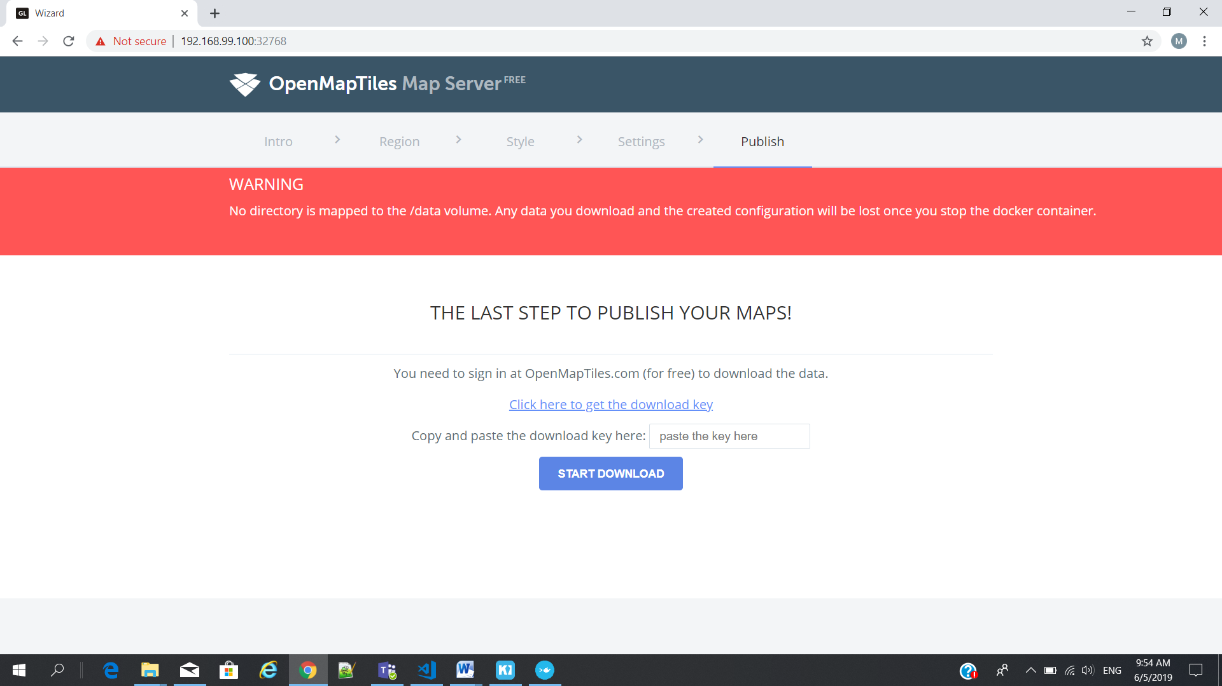

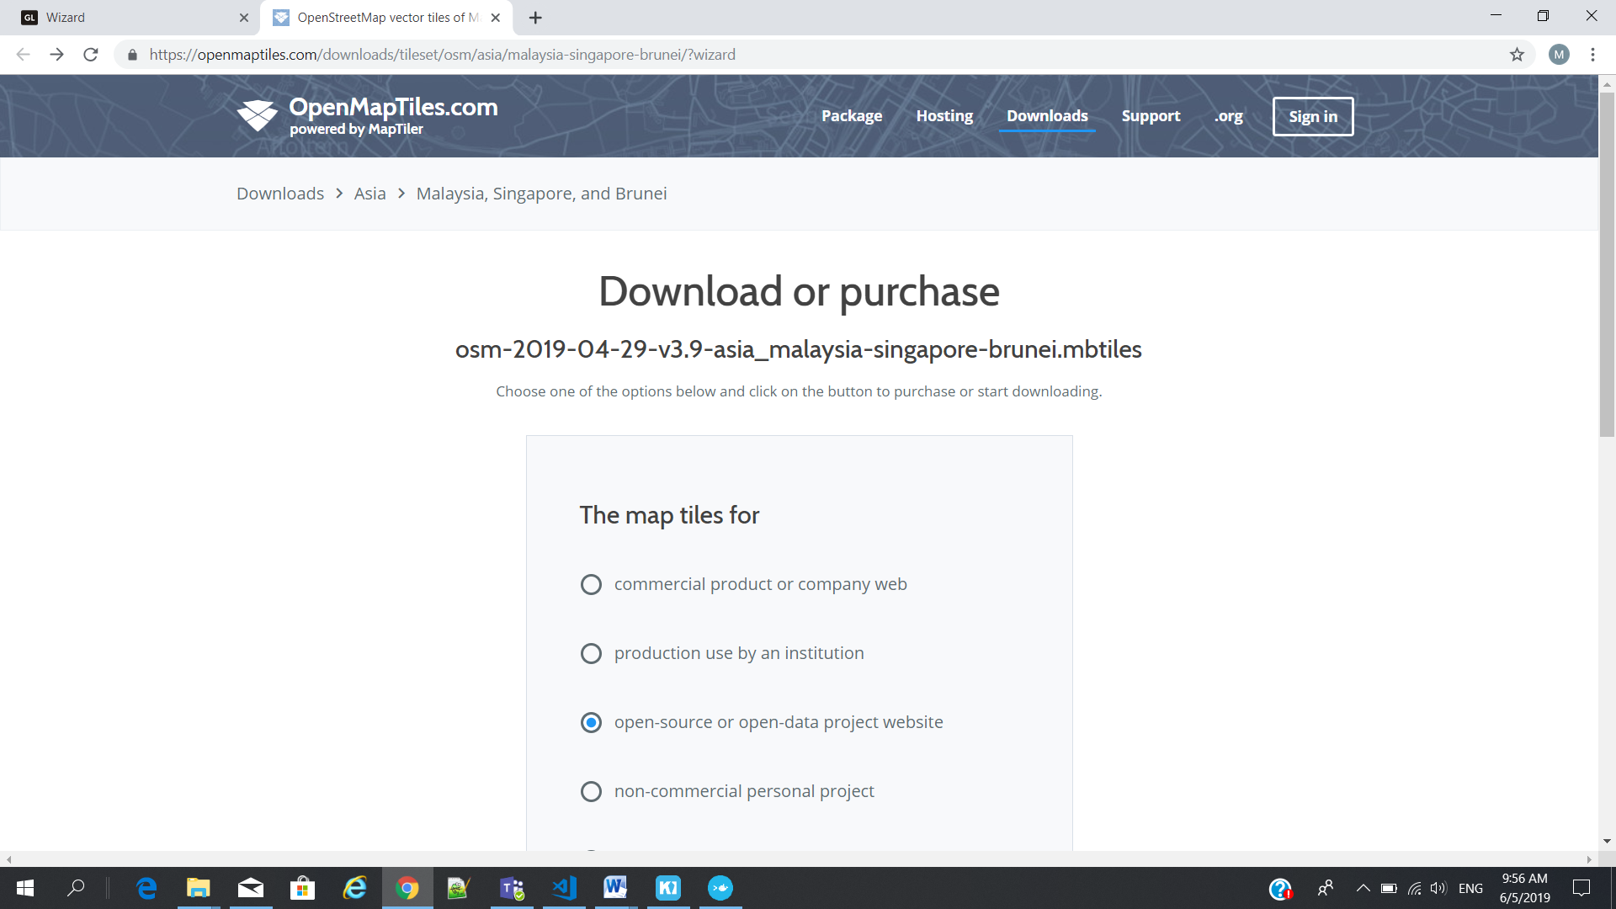

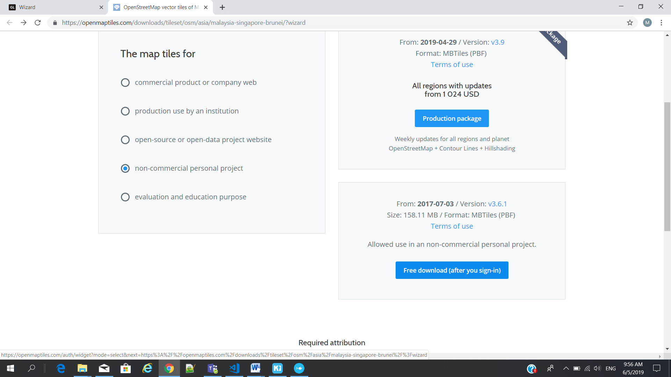

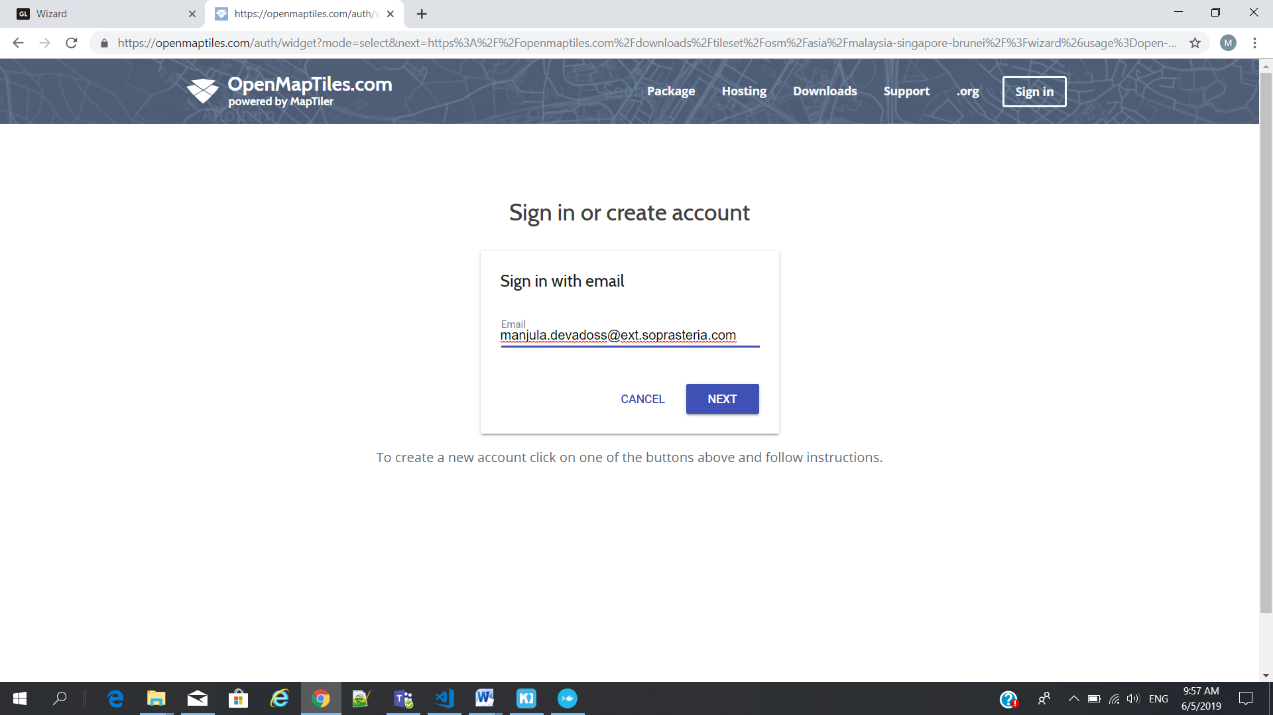

# Postgres Database Creation

1. Right click from Batabases(3)
2. Choose new Database

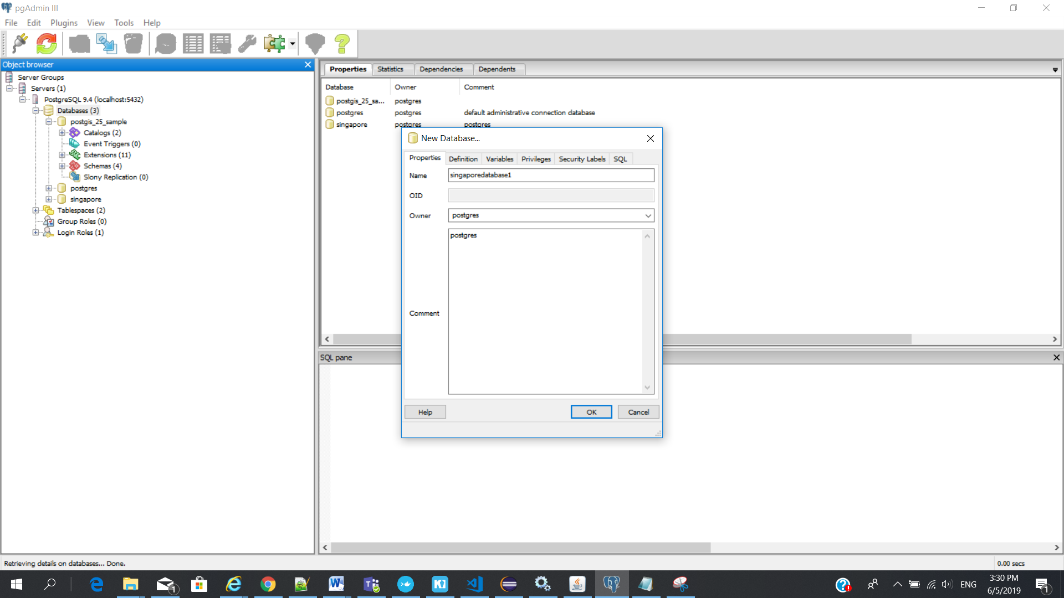

Template as - "postgis_25_sample"

Tablespace - pg_default

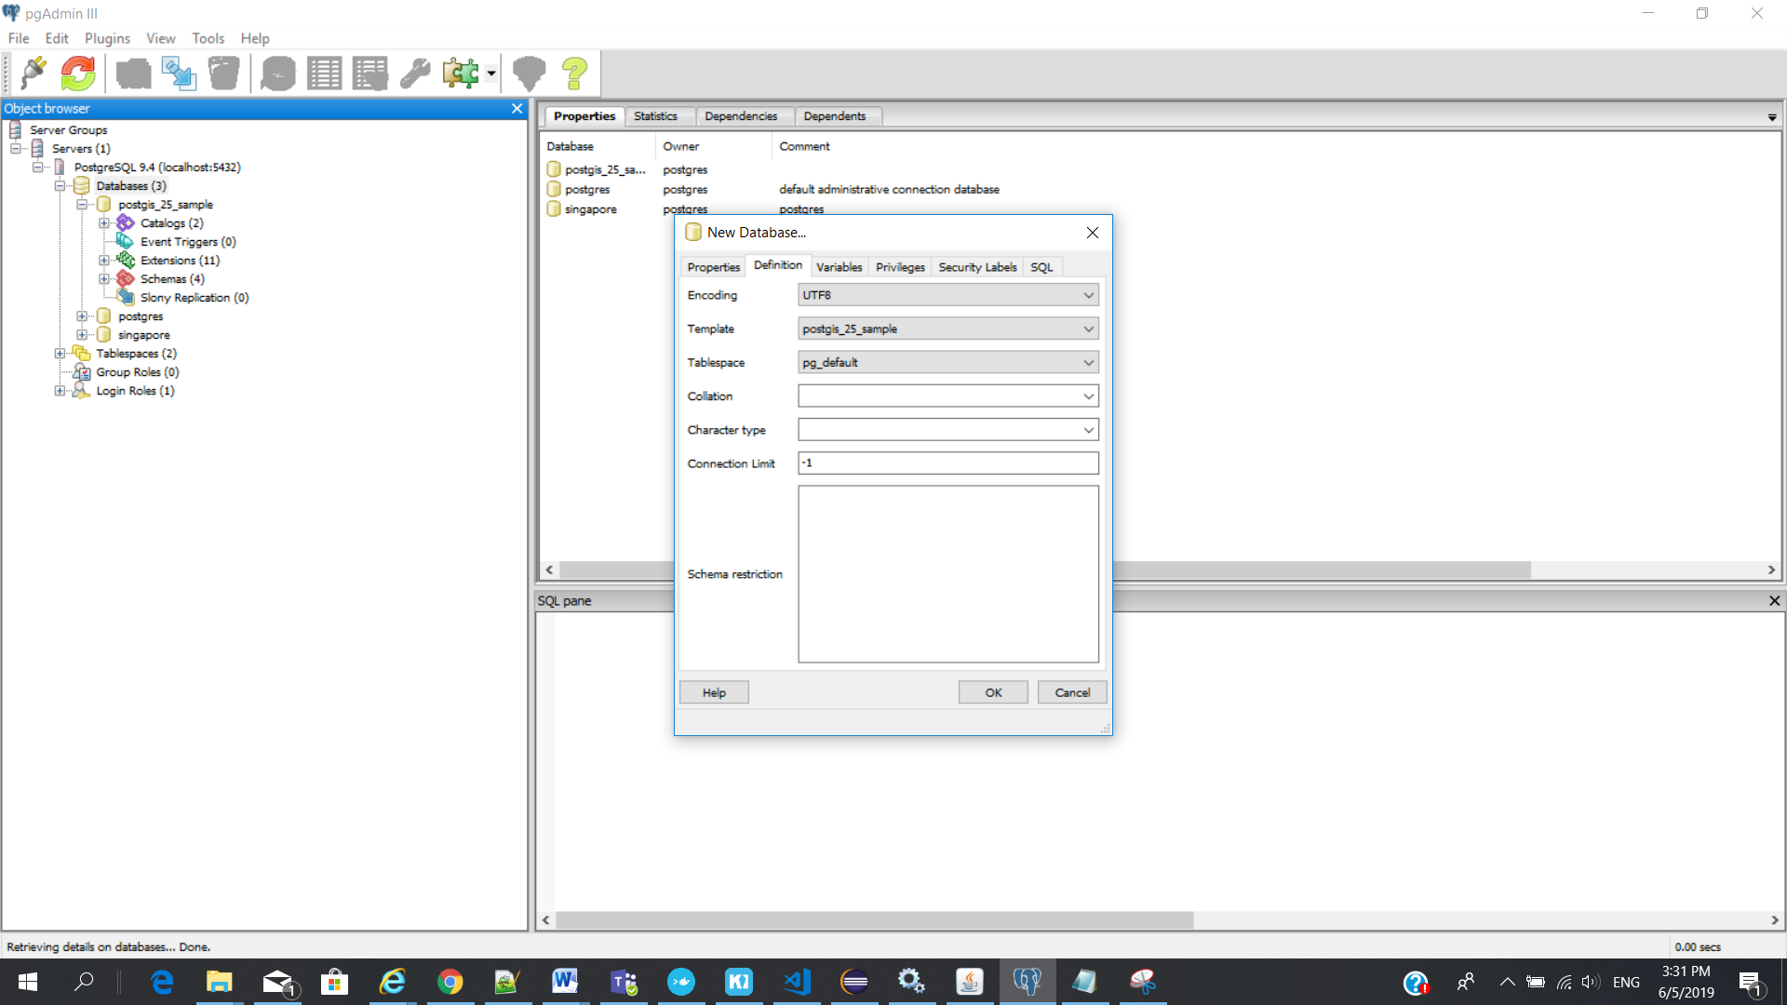

Make sure when you choose “postgis_25_sample” - Disconnect Database – cross icon on the label name

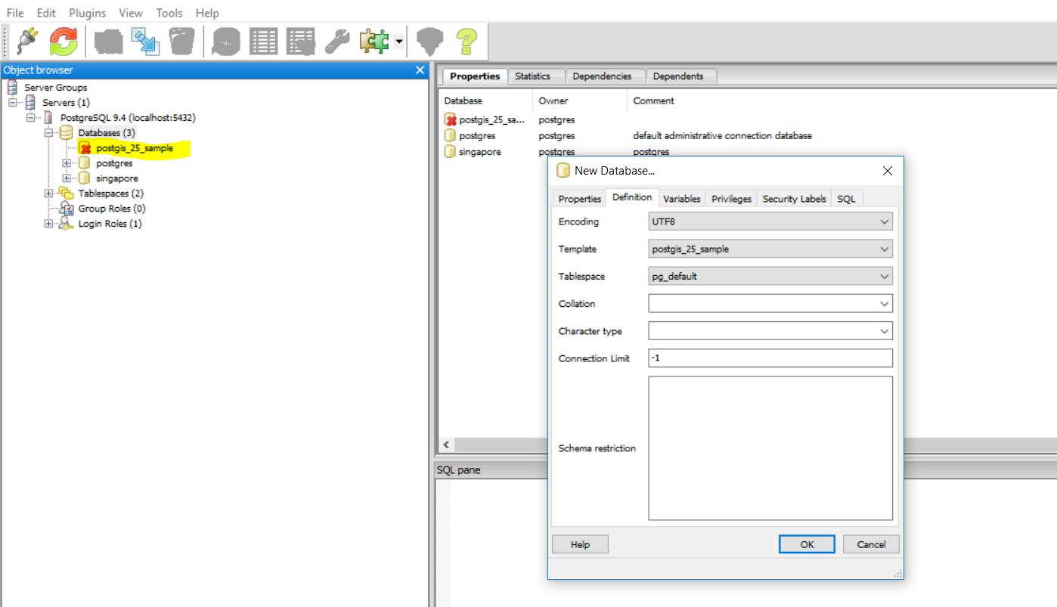

New database : singaporedatabase1

---- Singaporedatabase1

-------- Schemas

---------- Tables

--------- pointcloud_frmats(table)

---------- saptial_ref_sys(table)

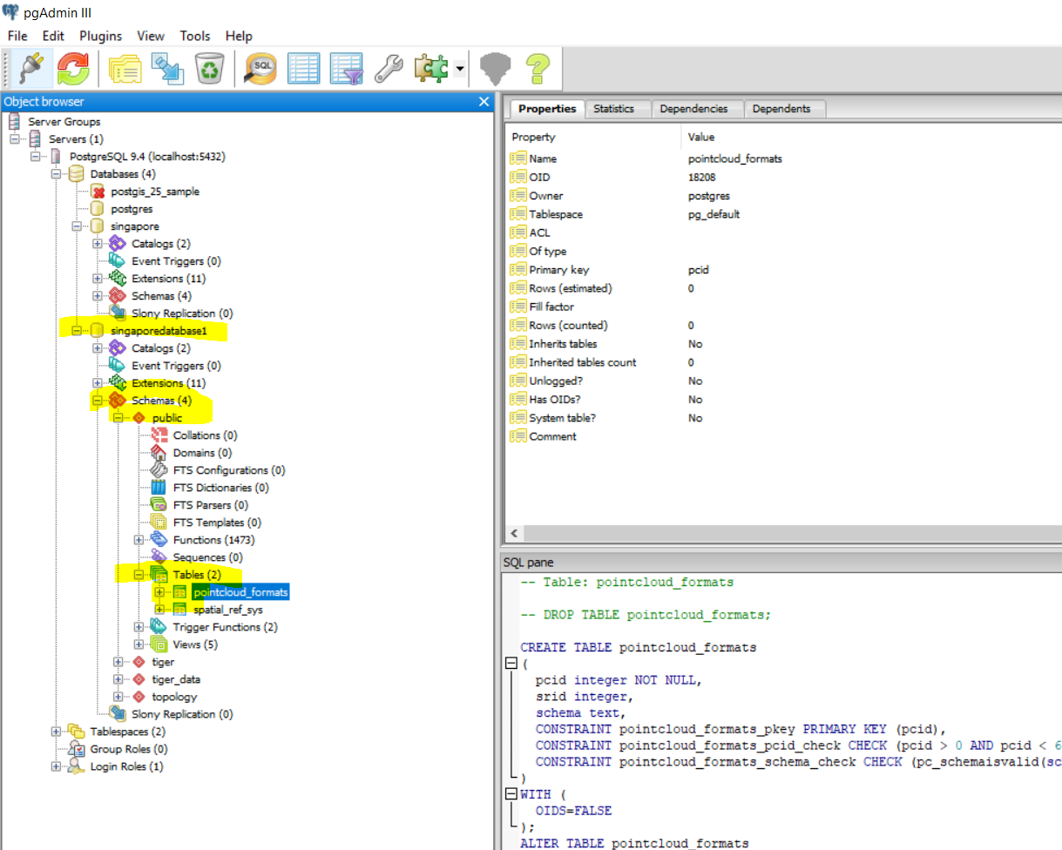

# Geoserver and database setup

Login to Geoserver ()

1. Click Workspace

Add new workspace

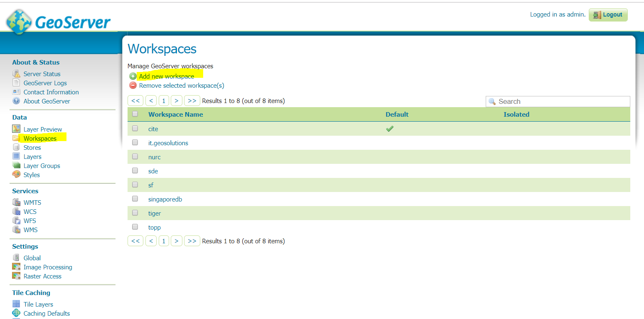

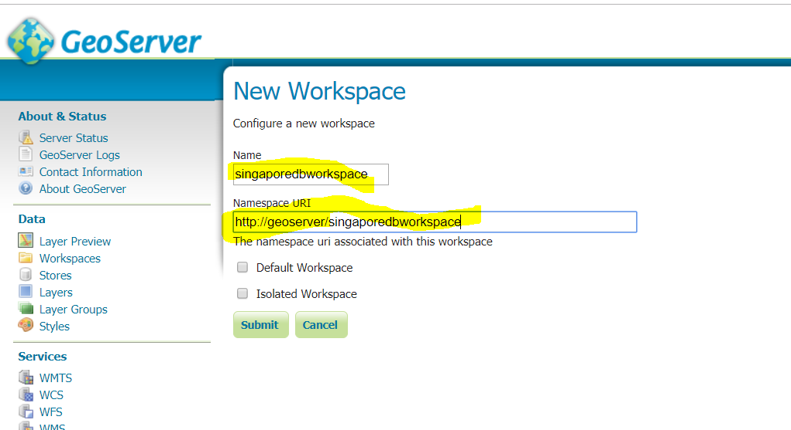

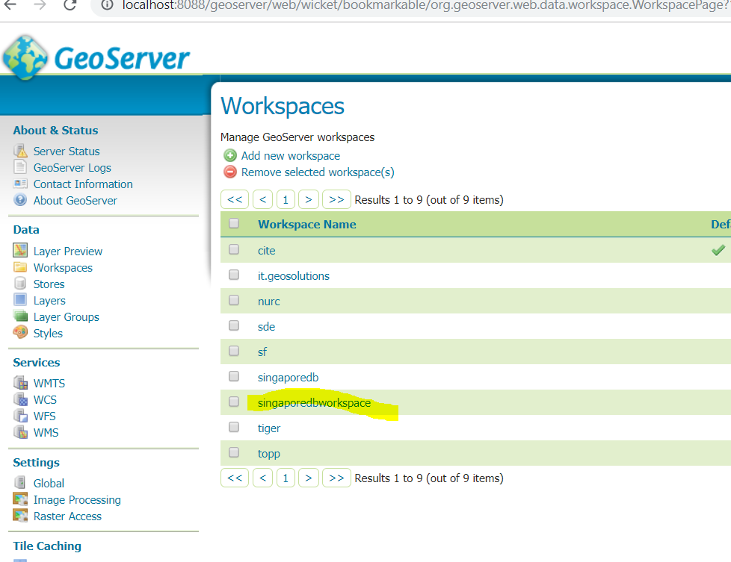

Services :

WMTS – Basemap (openmaptile server)

WMS – Additional layer (geoserver)

1. Click stores

Add new store

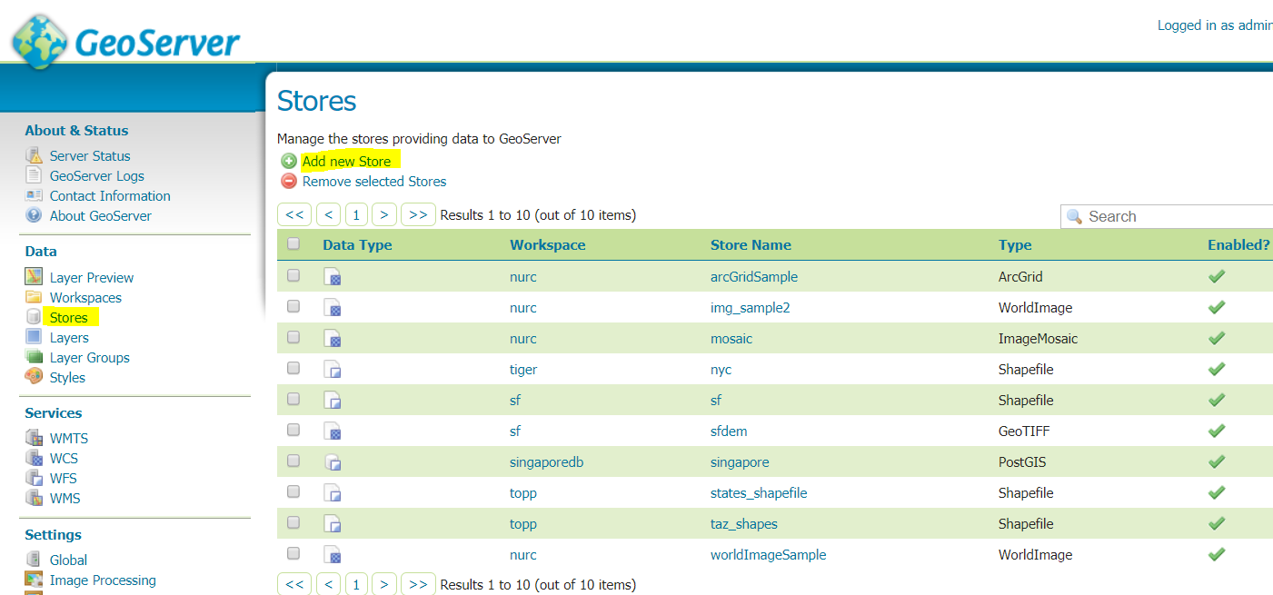

Choose :  [PostGIS](javascript:;)- PostGIS Database

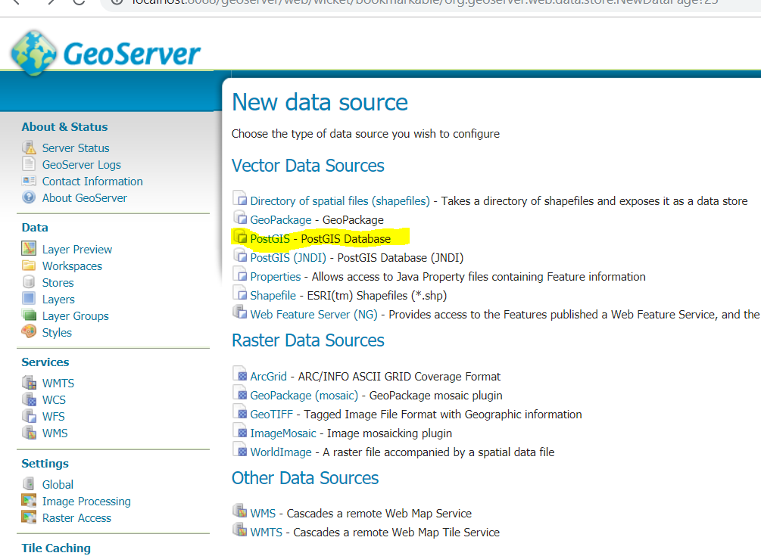

Click stores

Workspace – choose your workspace

Data Source Name – choose your data base name

Database – name of your database

User : postgres

password : postgres

maxconnection : 20

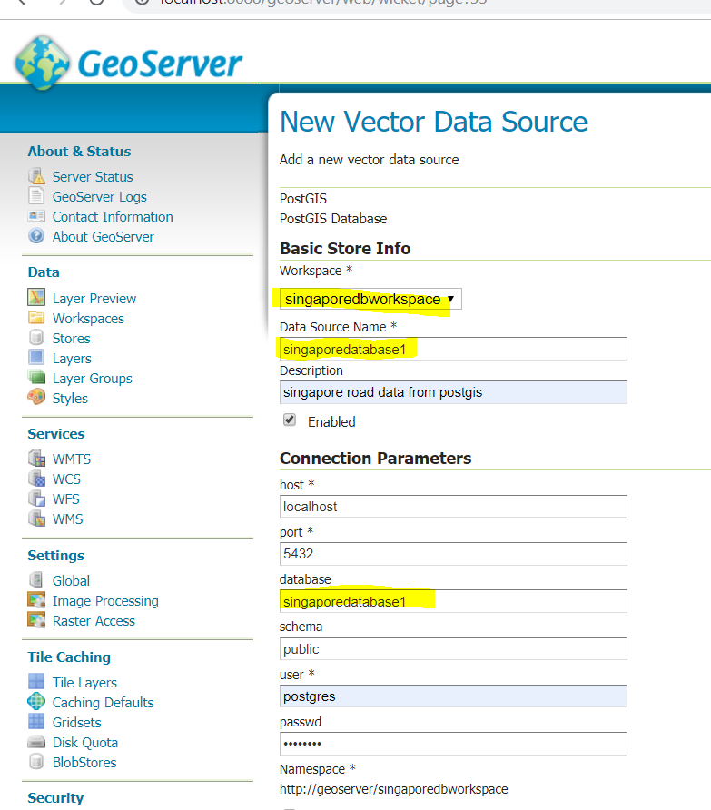

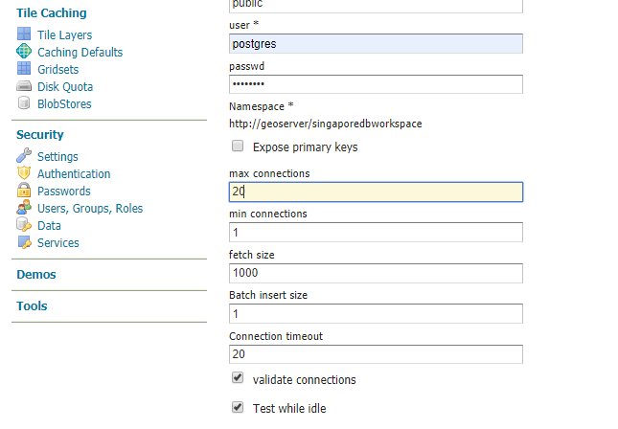

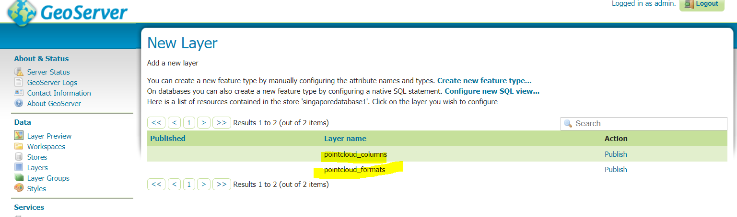

Layer will display : pointcloud_columns table (check with postgres db)

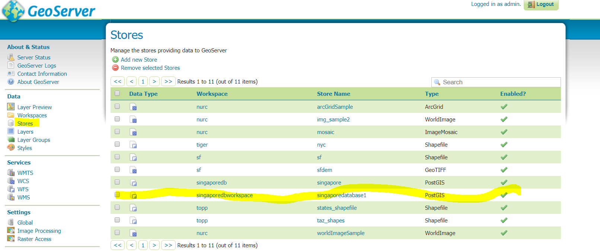

1. Click Layer

Add a new layer

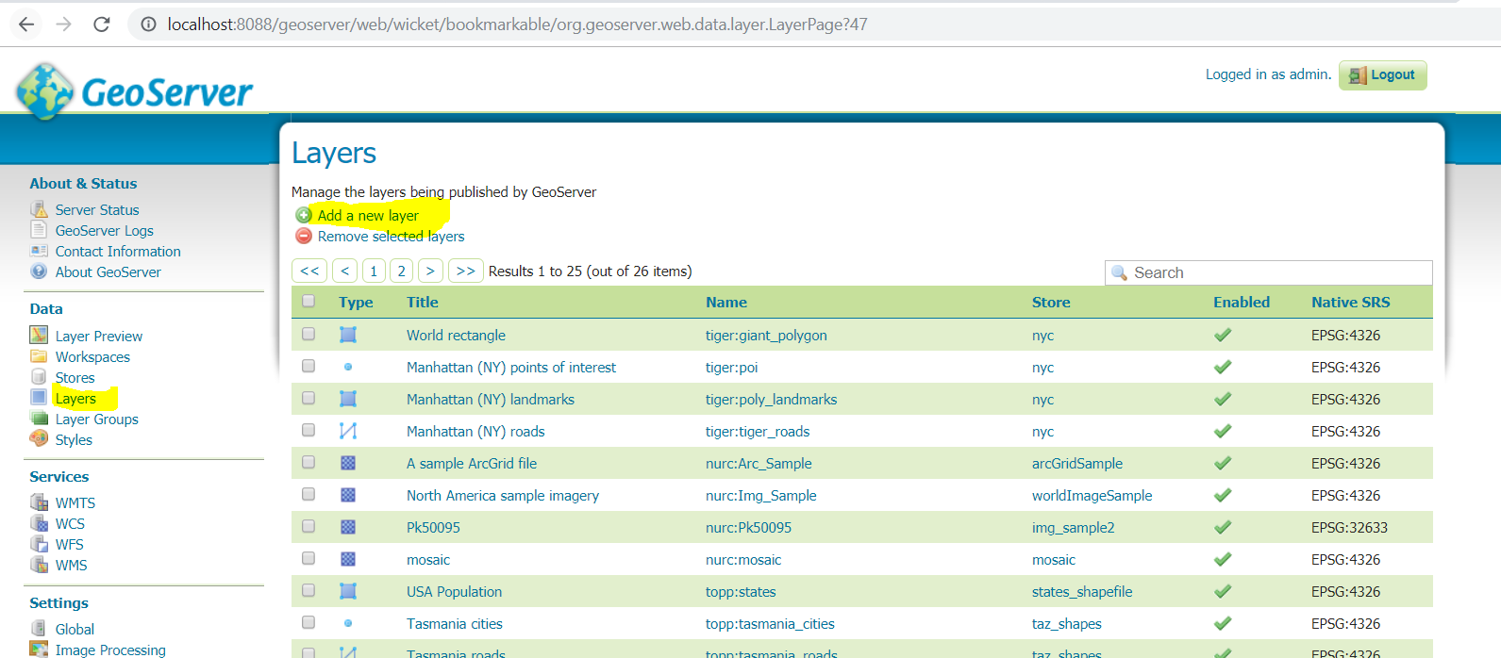

Choose you workspacename

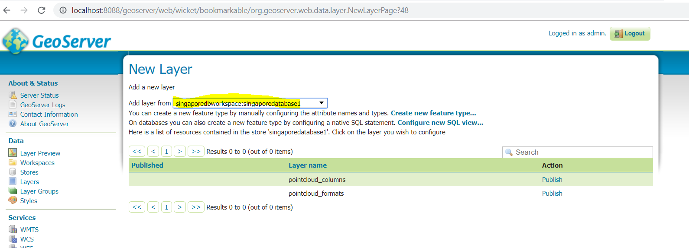

1. Click Layer Preview – to view the layer on the map

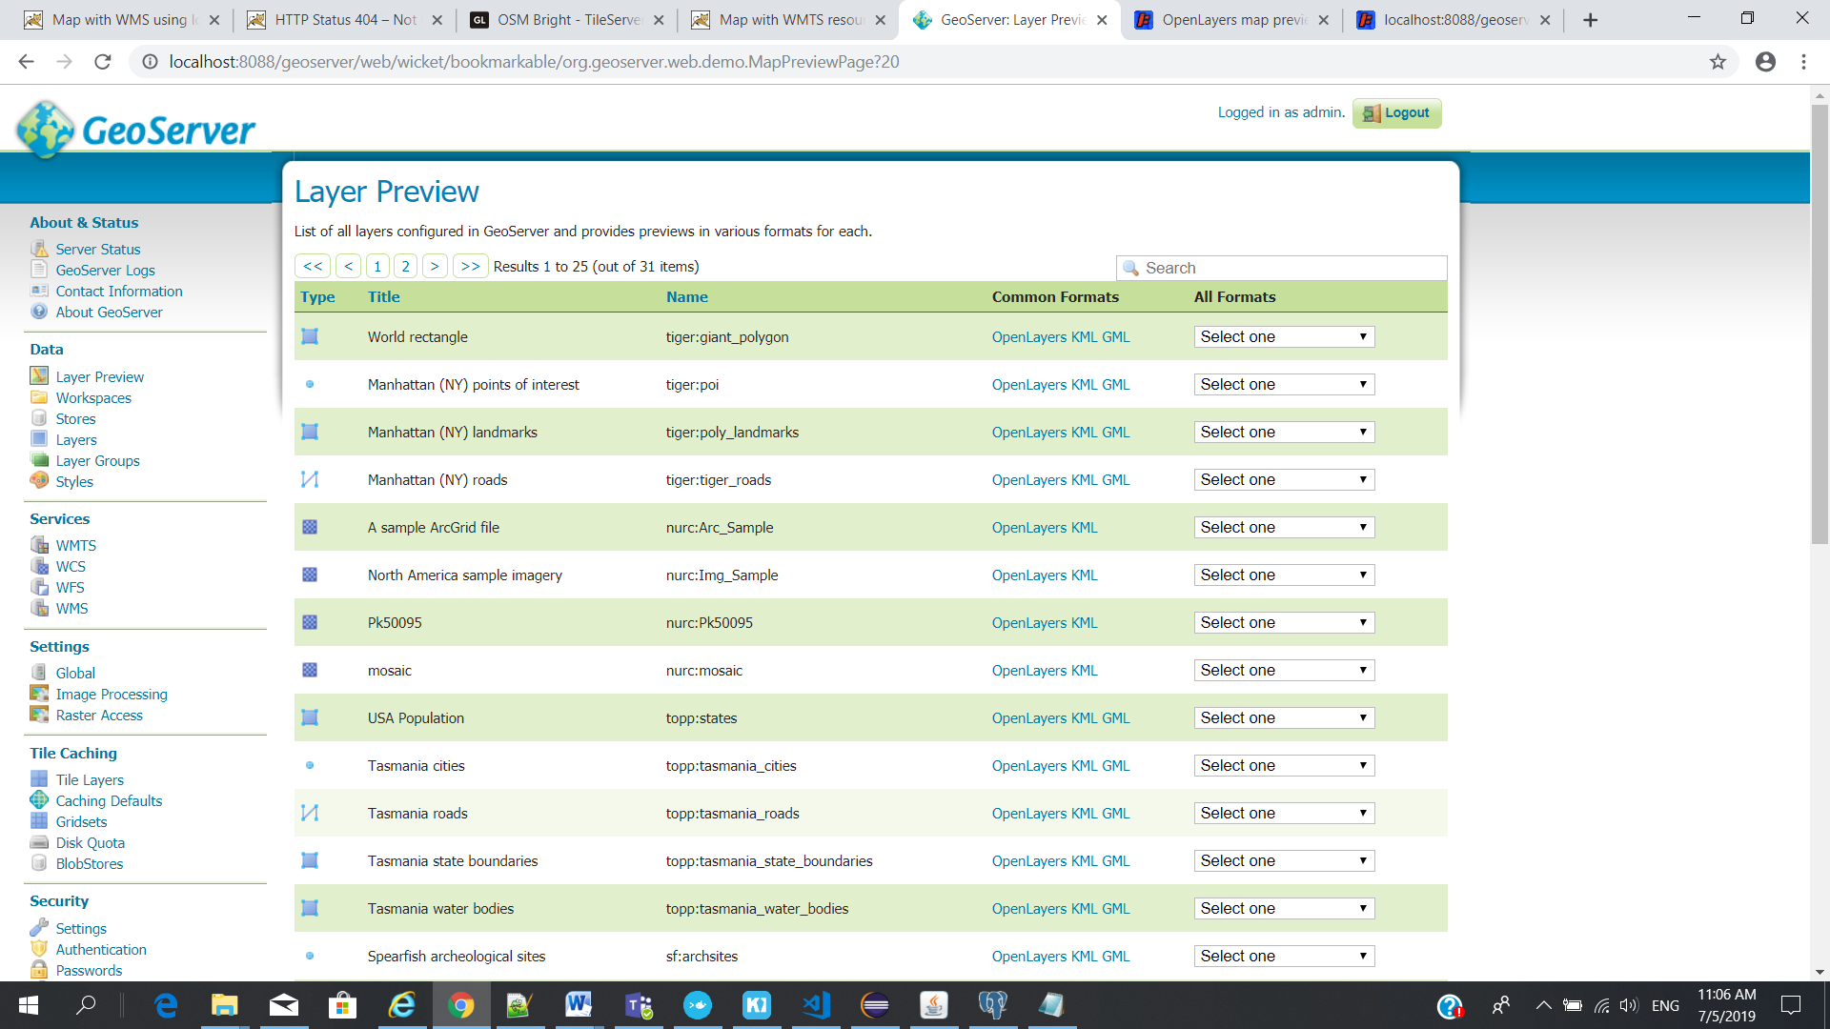

Top of Form